Test 4

Set-6

S.K. LOHIT DEVESHWAR

192211054

CSA0272 C Programming

For print spoolers

1st Question

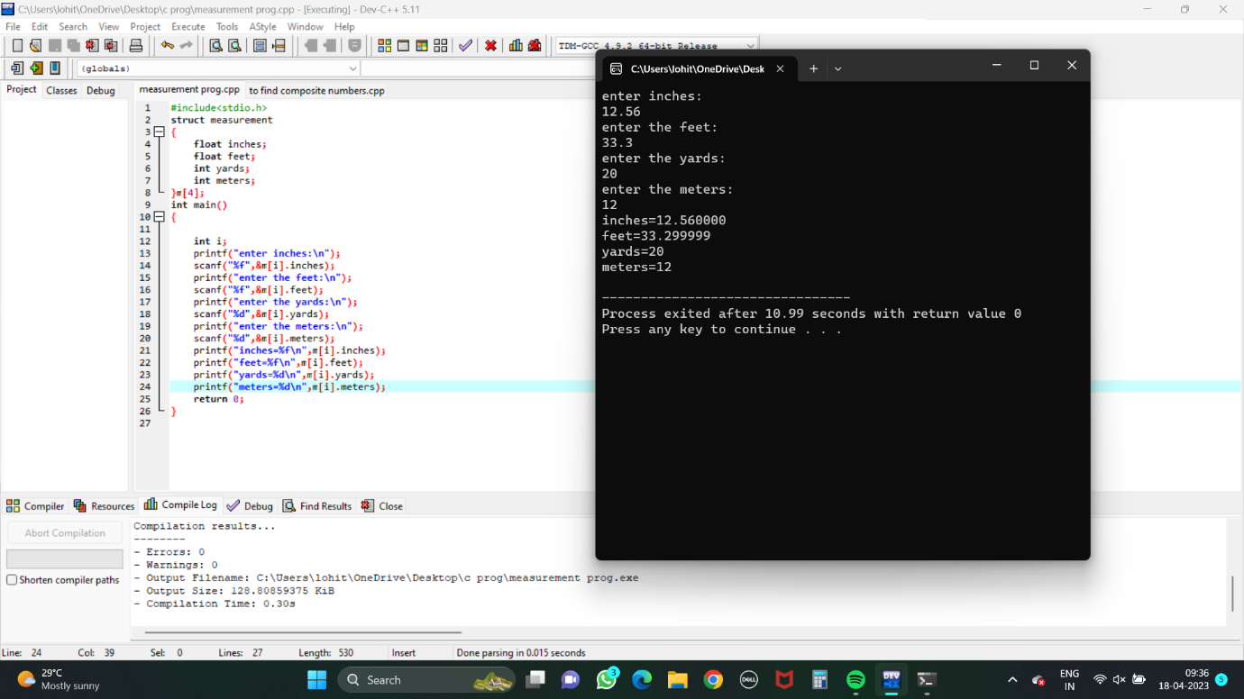

2nd Question

